Picture source:

Couch pillows:

<https://www.crateandbarrel.com/trevino-delfe-blue-20-pillow-with-down-alternative-insert/s648405>

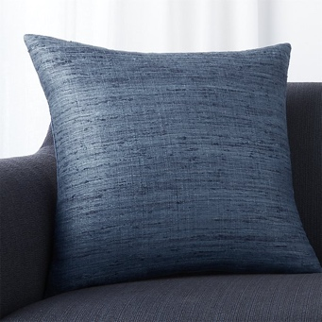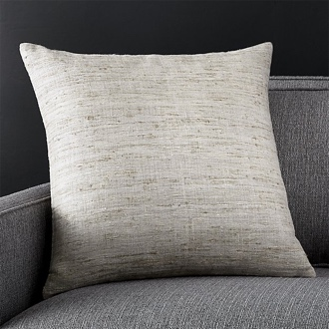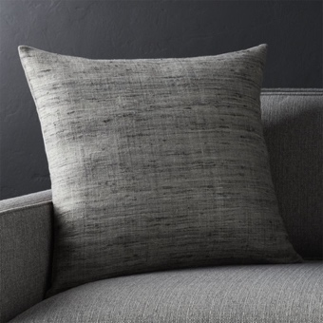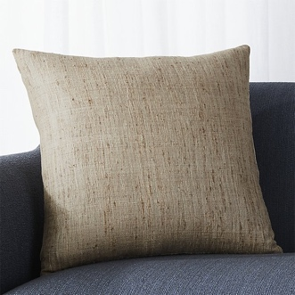

Bed pillows:

<https://www.dormify.com/collections>

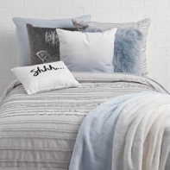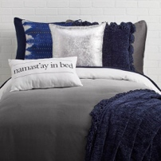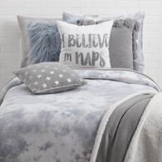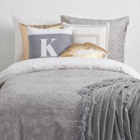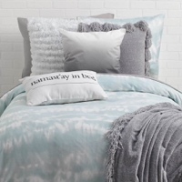

Round Pillows

[https://www.pbteen.com/products/cozy-pom-pillow](https://www.pbteen.com/products/cozy-pom-pillow/?catalogId=64&sku=5324897&cm_ven=PLA&cm_cat=Google&cm_pla=Girls%20Bedding%20%3E%20Decorative%20Pillows&cm_ite=5324897&gclid=EAIaIQobChMIxI3qz6Cq3gIV0VqGCh0CVwNOEAQYHCABEgJBvfD_BwE)

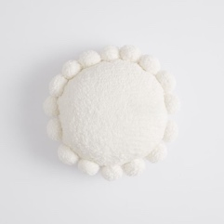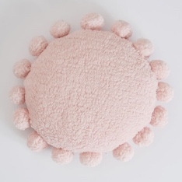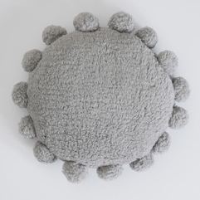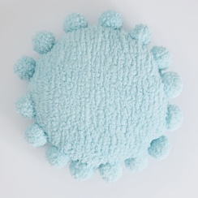

Floor poufs:

<https://www.westelm.com/products/rani-rug-pouf-t4632/?pkey=cfloor-pillows&isx=0.0.185>

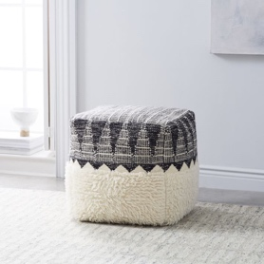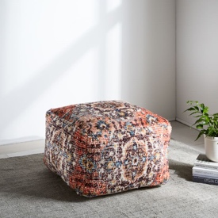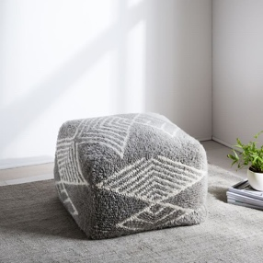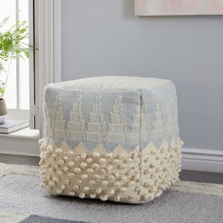

Previous Citations: 